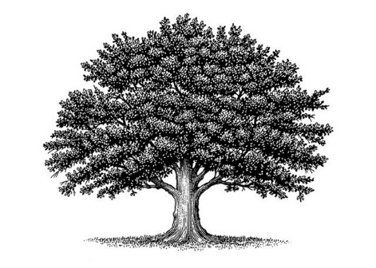

Deed of Land Recording

[insert Identity number here; keep brackets]

South African Republic Common Law Copyright and Trademark of Trade Name

Mary Jane Doe

On the [date, remove brackets] day of [Month, remove brackets] in the year 2025 at the hour and minute of [time of birth, remove brackets] a.m. /p.m., a new baby boy/girl was born on the land commonly known as Southern Africa, [suburb, remove brackets] District, [province, remove brackets] Province or foreign country: [state which country, remove brackets]

Born to the [surname, remove brackets] Family and was given the name: [first names, remove brackets]

The private natural biological parents are: [fathers full name, remove brackets],

Father, born on the [date, remove brackets] day of [month, remove brackets] in the year 19 on the land of Southern Africa, [suburb, remove brackets] District, [province, remove brackets] Province or foreign country: [Country of birth if not SA]

&

[mothers name [born: maiden name, keep brackets], remove brackets] Mother, born on the [date, remove brackets] day of [month, remove brackets] in the year 19 on the land of Southern Africa, [suburb, remove brackets] District, [province, remove brackets] Province or foreign country: [Country of birth if not SA]

And were married at common law land jurisdiction.

The family lives in the [suburb, remove brackets] District, [province, remove brackets] Province near [major town remove brackets] Town and in care of the mailing address:

[street address, remove brackets]

This baby is their first/second living child and first/second son/daughter.
So said, signed, and sealed this 25th day of May 2024 at Johannesburg, Transvaal/Gauteng, South African Republic.

Autograph & Seal: by _ _ _ _ _ _ _ _ _ _ _ _ _ _ _ _ _ _ _ _ _

Witness and Acknowledgement
On the land and soil of Southern Africa, South African Republic; I, a witness, there being no public notary available was visited today by the living wo/man known and identified as Mary Jane Doe and she/he did autograph and seal this Certificate of Assumed Name in my presence, and did affirm the same in my sight, whereupon I affix my autograph and seal as testimony to these facts.

We are living Witnesses to the Declarant’s signature:

Witness 1: (printed name): Autograph: _ _ _ _ _ _ _ _ _ _ _ _ _ _ _ _

Email:

Witness 2: (printed name): Autograph: _ _ _ _ _ _ _ _ _ _ _ _ _ _ _ _

Email:
_ _ _ _ _ _ _ _ _ _ _ _ _ _ _ _ _ _ _ _ _ _ _ _ _ _ _ _ _ _ _ _ _ _ _ _ _ _ _ _ _ _ _ _ _ _ _ _ _ _ _ _ _ _ _ _ _ _ _ _ _ _ _ _ _ _ _ _ _ _
(b) Public Notary:
I, a Recording Secretary and International Notarial Witness approved by The Land Recording Office, South Africa hereby affirm that the Declarant has been positively identified, and I have witnessed their autographing of this Universal Public Declaration of Political Status
Established under International- and National Law document.

on this ………. Day …………. Month……………. Year

By…………………………….

Public Notary Printed name
_ _ _ _ _ _ _ _ _ _ _ _ _ _ _ _ _ _ _ _ _ _ _ _ _ _ _ _ _ _ _ _ _ _ _ _ _ _ _ _ _ _ _ _ _ _ _ _ _ _ _ _ _ _ _ _ _ _ _ _ _ _ _ _ _ _ _ _ _ _

Matthew 18:16 But if he will not hear thee, then take with thee one or two more, that in the mouth of two or three witnesses, every word may be established.

